LED Watch Project Requirements:
-Manufactured PCB (After testing with bread board)
- Bread Board
- Bread Board Wires
- Arduino/ Arduino Copy (Microcontroller) (ATMega328, STC15W408AS)
- an RTC (S3231)
- Orange LED Seven Segment Displays
- Capacitors/ Resistors
- a crystal oscillator
- an enclosure (i.e 3-D printing enclosure from the other guy)
- a soldering iron
- solder
- wire cutters
- Buttons
- Battery (CR2032)
- Wrist Strap ( nylon or adjustable Velcro Strap)
- Circuit Design

Your list is quite solid for an LED watch project! Here's a refined version with a few suggestions and clarifications to ensure completeness and clarity:

✅ Refined LED Watch Project Requirements
🧠 Core Electronics
- Microcontroller: Arduino or compatible board (e.g., ATMega328, STC15W408AS)
- Real-Time Clock (RTC): DS1302 (consider DS3231 for better accuracy and ease of use)
- Seven-Segment Displays: Orange LED type (common cathode or anode—match with your circuit)
- Crystal Oscillator: For RTC timing (typically 32.768 kHz for DS1302)
- Capacitors and Resistors: As needed for display current limiting, RTC stability, etc.
- Buttons: For setting time or switching modes
🔧 Prototyping & Assembly
- Breadboard: For initial testing
- Breadboard Wires: Jumper wires for connections
- Manufactured PCB: After successful breadboard testing
- Soldering Iron & Solder
- Wire Cutters / Strippers
🔋 Power & Housing
- Battery: CR2032 (not ACR2032—likely a typo)
- Battery Holder: For CR2032
- Enclosure: 3D-printed case or custom housing
- Wrist Strap: Nylon or Velcro
🧩 Design & Planning
- Circuit Design: Schematic and PCB layout (e.g., using KiCad or EasyEDA)

🛠 Optional but Helpful Additions
- USB-to-Serial Adapter: If using bare microcontroller (e.g., ATMega328 without USB)
- Programming Tools: Arduino IDE or equivalent
- Heat Shrink Tubing: For wire insulation
- Multimeter: For debugging and testing

⚠️ Notes
- Double-check compatibility between your microcontroller and RTC/display modules.
- Consider power-saving strategies if you want longer battery life.
- If you're using a bare ATMega328, you'll need to flash the bootloader and handle power regulation.

Let me know if you want help with the circuit diagram or code for the watch logic!

Absolutely — this LED watch project is a fantastic addition to an electrical engineering student's resume. Here's why it stands out:
🎯 Why It’s Resume-Worthy
1. Demonstrates Breadth of Skills
- Circuit Design: Shows understanding of analog and digital components.
- Microcontroller Programming: Highlights embedded systems experience.
- PCB Design & Fabrication: Indicates proficiency with tools like KiCad or Eagle.
- Soldering & Assembly: Hands-on hardware skills.
- Power Management: Battery integration and low-power design.
- Timekeeping Logic: Real-time clock interfacing and time display logic.
2. Project-Based Learning
- Employers love seeing end-to-end projects — from concept to prototype to final product.
- It proves you can plan, troubleshoot, and iterate, which is more valuable than just coursework.
3. Portfolio Potential
- You can showcase:
  - Circuit schematics
  - PCB layout screenshots
  - Photos of the assembled watch
  - Code snippets (e.g., time-setting logic, display multiplexing)
  - A short video demo
4. Customization & Creativity
- Adding features like alarms, stopwatch, or Bluetooth sync would elevate it even further.
- A custom 3D-printed enclosure shows cross-disciplinary collaboration and design thinking.
📝 How to Frame It on Your Resume
Project Title: LED Watch with RTC and Microcontroller Tools Used: Arduino, KiCad, DS1302 RTC, ATMega328, 3D Printing Skills Demonstrated:
- Designed and fabricated custom PCB for wearable LED watch
- Programmed microcontroller to interface with RTC and seven-segment display
- Assembled and tested prototype using breadboard and soldered components
- Created enclosure using CAD and 3D printing
💡 Bonus Tip
If you present this project during interviews, be ready to talk about:
- Challenges you faced (e.g., power consumption, display flicker)
- How you debugged the circuit or code
- What you'd improve in version 2.0
TL;DR:
Yes — this project is a resume gem. It shows initiative, technical depth, and creativity. Just make sure you document it well and highlight the skills it demonstrates.
Want help writing the resume bullet points or a portfolio description? I’d be happy to help with that too.

Great question — and the answer depends on how much space you have and how relevant each project is. Here's a breakdown to help you decide:
🎓 Ideal Number of Projects for an EE Student Resume
✅ 1–3 Projects (Sweet Spot)
- 1 strong capstone or personal project that showcases deep technical skills.
- 1–2 supporting projects that highlight variety (e.g., hardware, software, teamwork, innovation).
This keeps your resume clean, focused, and impactful.
🧠 When to Include More (Up to 5)
- If you're applying for internships or entry-level roles and don’t have much work experience.
- If each project demonstrates different skills (e.g., embedded systems, signal processing, IoT, PCB design).
- If you’re tailoring your resume for a specific role (e.g., showing more coding-heavy projects for firmware roles).
🚫 Avoid Overcrowding
- Don’t list every lab assignment or minor build — it dilutes the impact.
- Prioritize quality over quantity: choose projects where you played a key role, solved real problems, or built something impressive.
📝 How to Make Projects Stand Out
Each project should include:
- Title: Clear and descriptive
- Tools/Technologies: e.g., Arduino, MATLAB, KiCad, C++
- Key Contributions: What you did, not just what the team did
- Outcome: What you built, learned, or achieved
💡 Bonus Tip
If you have more projects, consider creating a portfolio website or a GitHub profile and link to it from your resume. That way, you keep the resume lean but still show off your full range.
Want help writing one of your project descriptions or organizing your resume layout? I’d be happy to help with that too.

Building your LED watch project is surprisingly affordable, especially if you're sourcing parts individually or using budget-friendly alternatives. Here's a breakdown of estimated costs based on current prices:

💸 Estimated Cost Breakdown
Component | Estimated Cost (USD)
Arduino (Uno/Nano or clone) | $5–10
RTC Module (DS1302) | $2–4
4-Digit Seven Segment Display | $2–5
Breadboard + Jumper Wires | $5–8
Capacitors/Resistors | $2–3 (bulk pack)
Crystal Oscillator (32.768 kHz) | $1–2
Buttons | $1–2 (pack of 5–10)
CR2032 Battery + Holder | $2–4
Wrist Strap (Velcro/Nylon) | $3–6
Soldering Iron | $10–20
Solder + Wire Cutters | $5–10
PCB Manufacturing (optional) | $5–15 (per board)
3D Printed Enclosure | $5–10 (depends on design)

🧾 Total Estimated Cost
- Basic Prototype (Breadboard only): ~$30–40
- Finished Watch (with PCB + enclosure): ~$50–70
Prices vary depending on quality, quantity, and where you buy (e.g., Amazon, AliExpress, local electronics stores).

💡 Cost-Saving Tips
- Use an Arduino clone or bare ATMega328 chip to cut costs.
- Buy components in bulk or kits.
- Share 3D printing resources with classmates or makerspaces.

Don't Forget:
If you're planning to showcase this project, investing a bit more in a polished enclosure and clean PCB layout can make a big difference in presentation and durability.
Want help sourcing parts or finding the cheapest bundle online? I can help with that too.

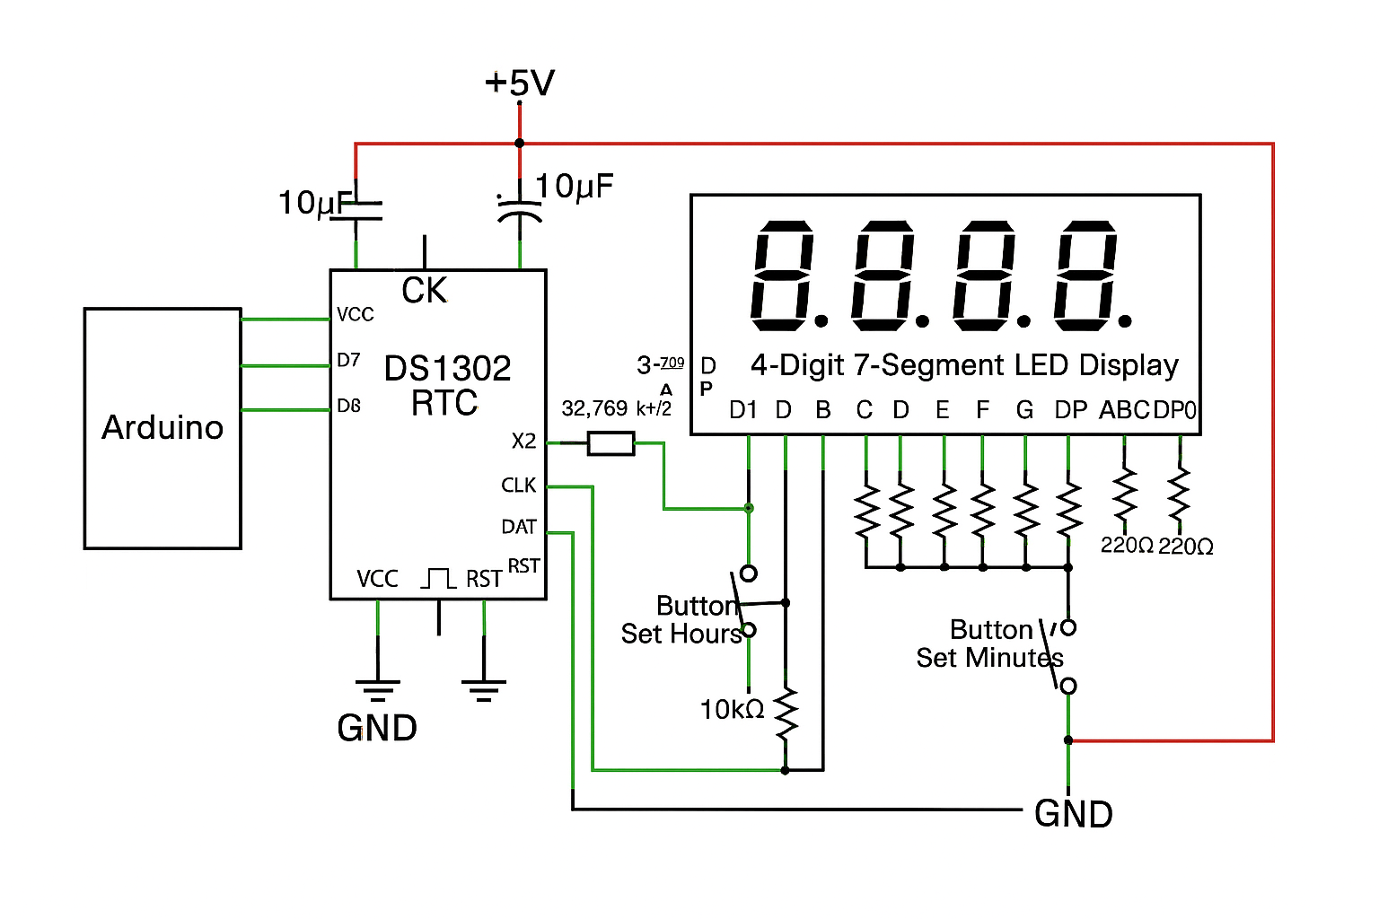
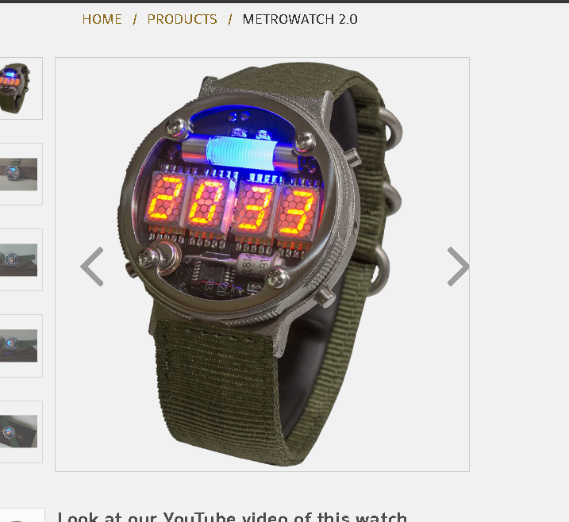
Great question — your LED watch project touches on several foundational areas from that list, but not all. Here's a breakdown of what you're likely to cover and what would require deeper or more specialized projects:
✅ Areas You Will Cover
🔧 Hands-on electronics design, prototyping, test, and debug
- You’ll wire up components, test voltages, debug logic, and possibly use tools like multimeters or oscilloscopes.
- This is the heart of your project — building, testing, and refining a real circuit.
🧠 Signal integrity, layout, and grounding principles
- If you move from breadboard to custom PCB, you’ll start thinking about trace routing, grounding, and minimizing noise.
- Even basic layout choices (e.g., separating power and signal paths) introduce these concepts.
🛠️ Board & chip design tools (KiCAD)
- If you design a PCB for your watch, you’ll likely use KiCAD or similar tools.
- You’ll learn schematic capture, footprint assignment, and layout — a great intro to board design.
🟡 Areas You Might Touch Lightly
🧮 Digital signal processing (DSP), classical/modern controls
- Not core to a basic watch, but if you add features like gesture recognition, filtering sensor data, or adaptive brightness, you’ll dip into DSP territory.
🧪 Simulation tools (SPICE)
- If you simulate your power circuit or LED driver behavior before building, you might use SPICE.
- Most hobbyists skip this, but it’s a great learning opportunity if you want to go deeper.
🤖 AI/Machine Learning (Keras, PyTorch)
- Not relevant unless you add smart features — like gesture-based time display or predictive battery management.
- You’d need more processing power than an ATmega328P for meaningful ML.
❌ Areas Not Covered by This Project
🧠 Scripting and modeling in MATLAB, Simulink, LabVIEW
- These are used for high-level system modeling, control design, and industrial automation — not typical for a microcontroller-based watch.
🔌 Digital/FPGA design tools (Vivado, Libero)
- Your project uses a microcontroller, not an FPGA. These tools are for designing custom digital logic on programmable chips.
📡 Advanced simulation tools (CST, COMSOL, ANSYS HFSS/SIwave)
- These are for electromagnetic, thermal, and structural simulations — way beyond the scope of a wearable LED watch.
TL;DR:
Your project gives you real-world experience in prototyping, layout, and embedded design, and lays the groundwork for deeper skills in PCB design, signal integrity, and debugging. It’s a fantastic launchpad — and if you want to expand into DSP, AI, or simulation, you can build on this foundation.
Want suggestions for how to evolve this project into something that touches more of those advanced areas? I’d love to help you level it up.

Leveling up your LED watch to a 2.0 version opens up a ton of exciting possibilities — from smarter features to sleeker design. Here’s a curated list of upgrades you could explore, depending on your goals:

🧠 Smarter Functionality
🔹 Motion-Activated Display
- Add an accelerometer (e.g., MPU6050) to detect wrist movement and auto-activate the display.
🔹 Touch or Gesture Control
- Replace buttons with capacitive touch sensors or use IR for gesture-based input.
🔹 Alarm or Timer Features
- Program alarms using your RTC and add a buzzer or vibration motor for alerts.
🔹 Bluetooth Connectivity
- Use an HC-05 module or BLE board to sync time or receive notifications from a phone.

🔋 Power & Efficiency
🔹 Solar Charging
- Add a small solar panel to trickle-charge your battery.
🔹 Battery Level Indicator
- Use a voltage divider and analog pin to monitor battery health and display a warning.
🔹 Sleep Mode Optimization
- Refine your code to enter deep sleep when idle, waking only on interrupts.

🖼️ Display & Interface
🔹 OLED or LCD Upgrade
- Swap the 7-segment display for a 128x64 OLED for more flexible UI and graphics.
🔹 Custom Fonts or Icons
- With a graphical display, you can show icons, animations, or even your logo.
🔹 Color LEDs or RGB Backlight
- Add flair with RGB LEDs or multicolor segments.

🧰 Build & Design
🔹 3D Printed Enclosure
- Design a sleek case with button mounts and strap loops.
🔹 Water Resistance
- Seal the enclosure with silicone gaskets or epoxy for splash protection.
🔹 Magnetic Charging Port
- Add a magnetic pogo pin connector for easy charging.

🤖 Advanced Features (Stretch Goals)
🔹 Voice Activation
- Use a simple sound sensor or microphone module to trigger actions.
🔹 AI-Powered Features
- If you upgrade to ESP32 or Raspberry Pi Pico, you could experiment with basic ML models (e.g., gesture recognition).
🔹 GPS or Location Awareness
- Add a GPS module to log location or sync time via satellite.

TL;DR:
Your 2.0 watch could be smarter, sleeker, and more interactive — with motion sensing, touch control, solar charging, and even Bluetooth or OLED displays. Whether you want it to be a tech showcase or a stylish wearable, there’s a path forward.
Want help choosing which upgrade fits your current skill level and parts list? I can help you build a roadmap for Watch 2.0.

You could also make a 3-D Printed Pass Holder

